**Level Outlines II**

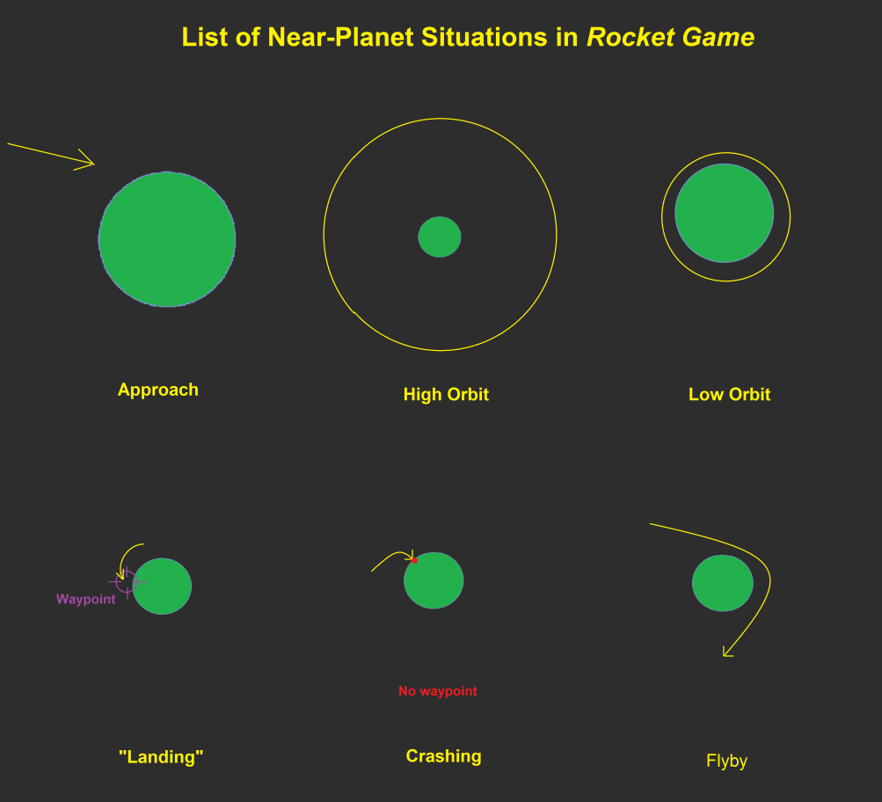

|  |  |  |  |  |
| --- | --- | --- | --- | --- |
| Level No. | Use map of level No: | Level Objectives | Teaching Content | Story Content  (If we’re doing this) |
| (Intro) | - | (cutscene) | - | Instructor is abducted |
| A | 1 | 1. Regain control of ship lost in space 2. Approach Earth. | *Game Controls | Astronaughts/students stuck because of autopilot malfunction /alien attack/whatever. |
| B | 1 | 1. Move a satellite from low orbit to high orbit around Earth. 2. Satellite suggests you to go to the Moon, so you go. Flyby. 3. Return to Low Earth Orbit and “land”. | *Newton’s Cannon Model  *Orbit terminology  *Hohmann transfer | Satellite repositioned to get better reception of an unusual signal.  It points towards the Moon and This might lead to the aliens that abducted the instructor.  On the moon is a crashed alien ship (we find out where the aliens went using it). |
| C | 1 | 1. Try to rendezvous with another craft that is orbiting the moon. There is a time limit. 2. Return to Low Earth Orbit. | *Gravitational potential energy and kinetic energy in orbits.  *Timing | This is the guy from mission A. He was not able to fly his rocket correctly and ran out of fuel during a moon orbit. You need to rescue him before he runs out of oxygen. |
| D | 4 | 1. Navigate through an asteroid field maze (very little gravity to worry about, most asteroids not moving). Fuel is very inefficient, and is used up quickly to change mass quickly. | *Newton’s Laws of motion | Searching for the aliens. |
| E | 3 | 1. Find the alien planet. 2. Flyby a number of planets in the correct order (maybe chasing an alien ship). | *Escape velocity  *Piloting skillz | You find the aliens and try to make a deal with them, but they run away.  They are impressed by your piloting skills after you successfully chase them and accept to return the instructor. |
| (End) | - | (cutscene) | - | Party! |